A Fantastic Visit to Healing Hills Farm!
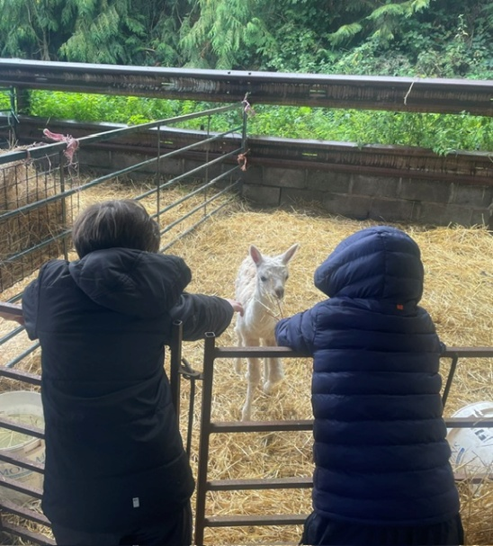
This week, we had a wonderful visit to Healing Hills Farm, where the children had the opportunity to meet the animals and experience some of the jobs involved in caring for them.
We had great fun taking the alpacas and sheep for a walk, although things didn’t always go quite according to plan! When some of the sheep made a bid for freedom, the children quickly sprang into action and helped to round up the escapees and return them safely to their pen!
There was plenty of hard work too. The children helped to feed the pigs and clean out their pens, getting a real taste of what it takes to look after animals properly. Everyone got stuck in brilliantly and approached each new task with enthusiasm.
This first visit was also a great opportunity for everyone to get to know the farm, the animals and their surroundings. Now that we know our way around, we are really looking forward to returning and getting stuck into even more activities next time.
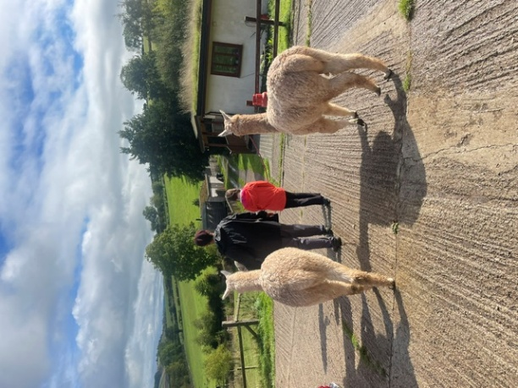
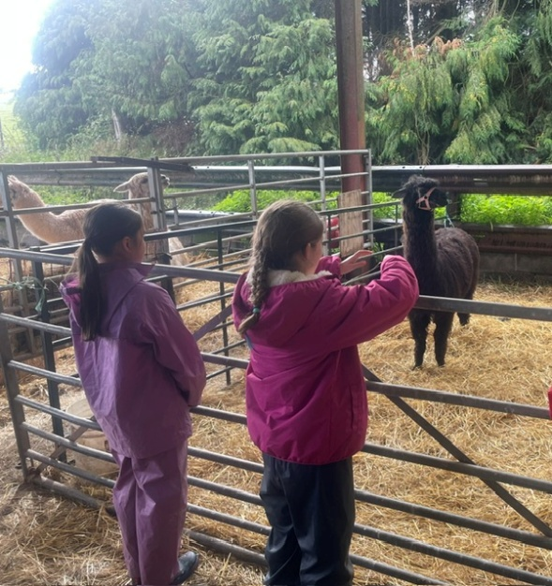
A huge thank you to everyone at Healing Hills Farm for making us feel so welcome. We can't wait to come back!
